Linux Bash Array Lab — Beginner to Real-Time Level
This lab will teach you:
- creating arrays
- adding/removing values
- looping arrays
- counting elements
- searching values
- real-world automation usage

LAB NAME
“Employee Salary Automation Using Arrays”
Imagine you are a Linux admin maintaining employee records.
STEP 1 — Create Lab File
mkdir array-lab
cd array-lab
touch employee.sh
chmod +x employee.sh
vim employee.sh
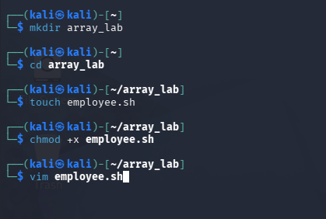

STEP 2 — Add This Script
#!/bin/bash

# Employee names array
employees=("Anamika" "John" "Sarah" "Mike")

echo "------ Employee Database ------"

# Print all employees
echo "All Employees:"
echo "${employees[@]}"

echo ""

# Print first employee
echo "First Employee:"
echo "${employees[0]}"

echo ""

# Count total employees
echo "Total Employees:"
echo "${#employees[@]}"

echo ""

# Add new employee
employees+=("David")

echo "Updated Employee List:"
echo "${employees[@]}"

echo ""

# Loop through employees
echo "------ Salary Distribution ------"

for emp in "${employees[@]}"; do
echo "Salary credited to $emp"
done
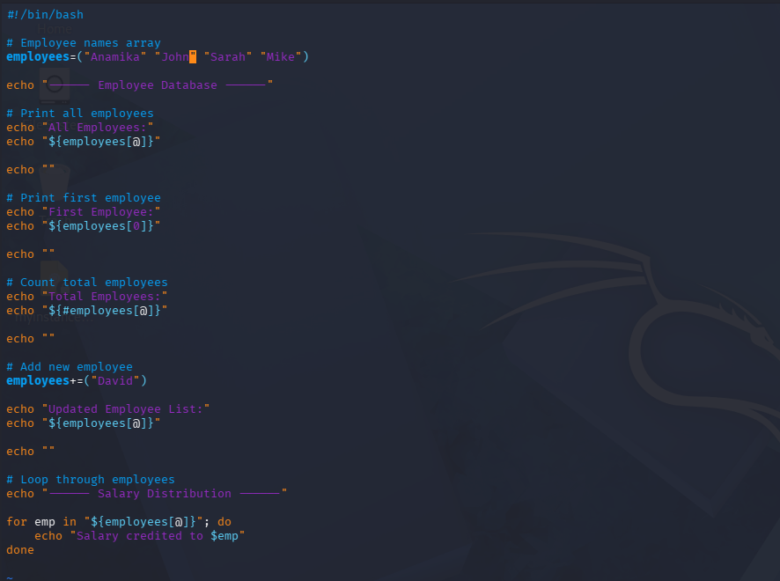

STEP 3 — Run Script
./employee.sh

Expected Output
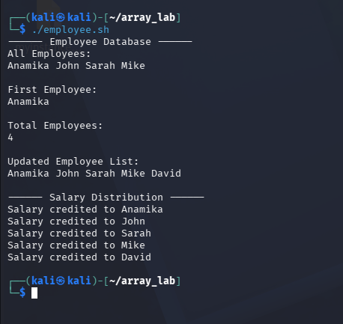

REAL-TIME TASKS
Now improve the script yourself.

TASK 1 — Remove Employee
Hint:
unset employees[2]
Then print updated array.
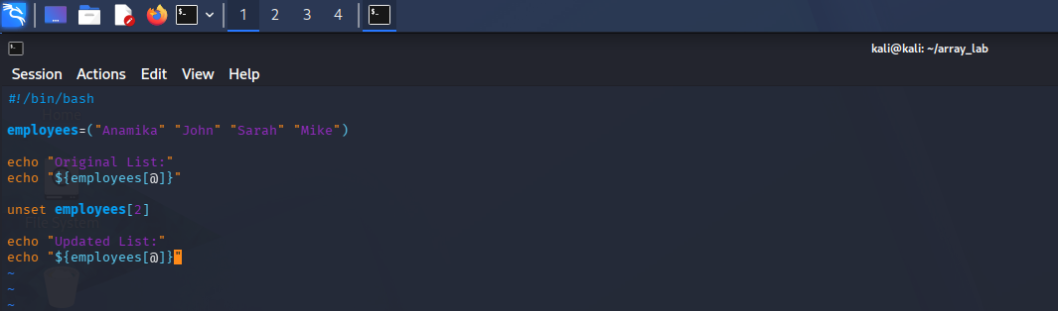
Expected output
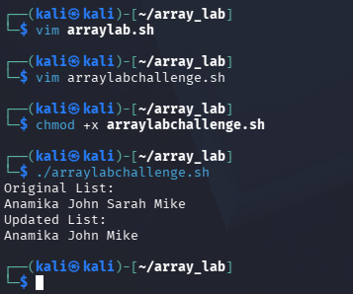

TASK 2 — Take User Input
Ask user to add employee dynamically.
Example:
read -p "Enter employee name: " newemp
employees+=("$newemp")
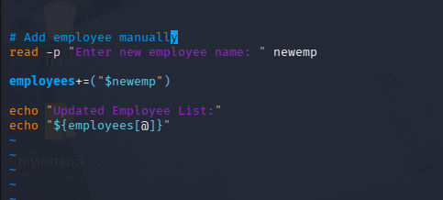
Expected Output:
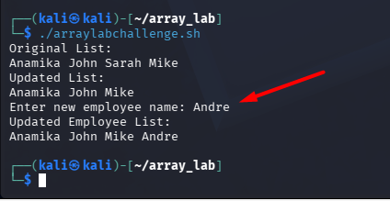

TASK 3 — Print Only Last Employee
Hint:
echo "${employees[-1]}"
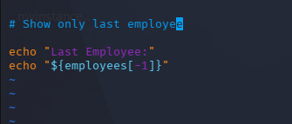
Expected output
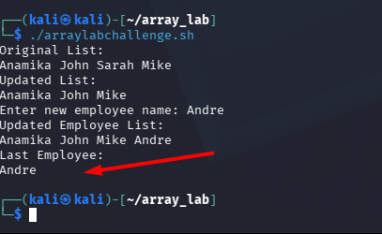

TASK 4 — Print Employee IDs
Create second array:
ids=(101 102 103 104)
Loop both arrays together.
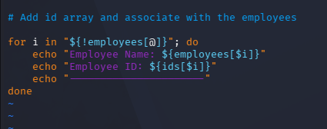

Expected output
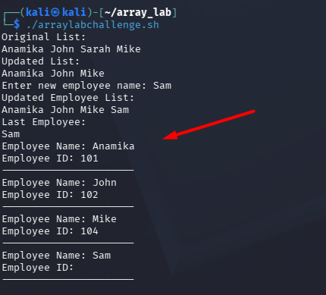

TASK 5 — Search Employee
Example:
search="John"
Check if employee exists.
Hint:
for emp in "${employees[@]}"
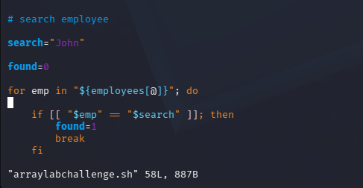
Expected output
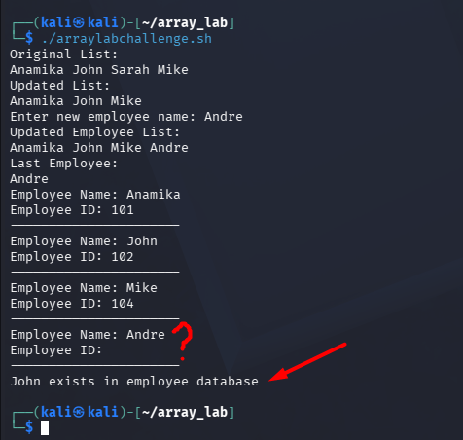

ADVANCED REAL-TIME LAB
Server Monitoring Using Arrays
Create script:
servers=("web1" "db1" "app1")
Loop:
ping -c 1 servername
Print:
- UP
- DOWN
This is REAL DevOps/Linux admin style usage.
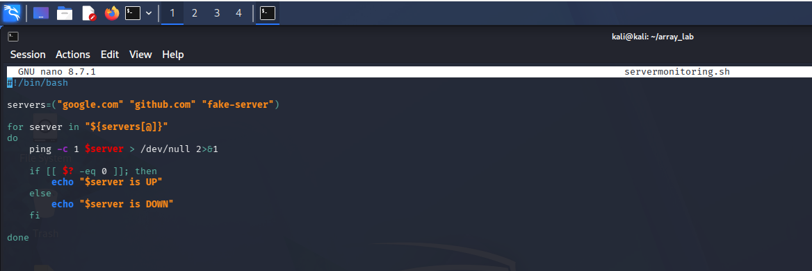
Expected Output
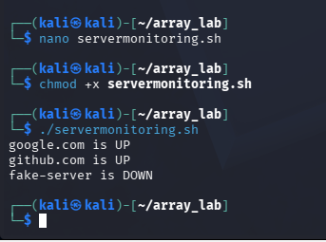

BONUS CHALLENGE
Create menu:
1. Add Employee
2. Remove Employee
3. Show Employees
4. Count Employees
5. Exit
This becomes mini employee management system.
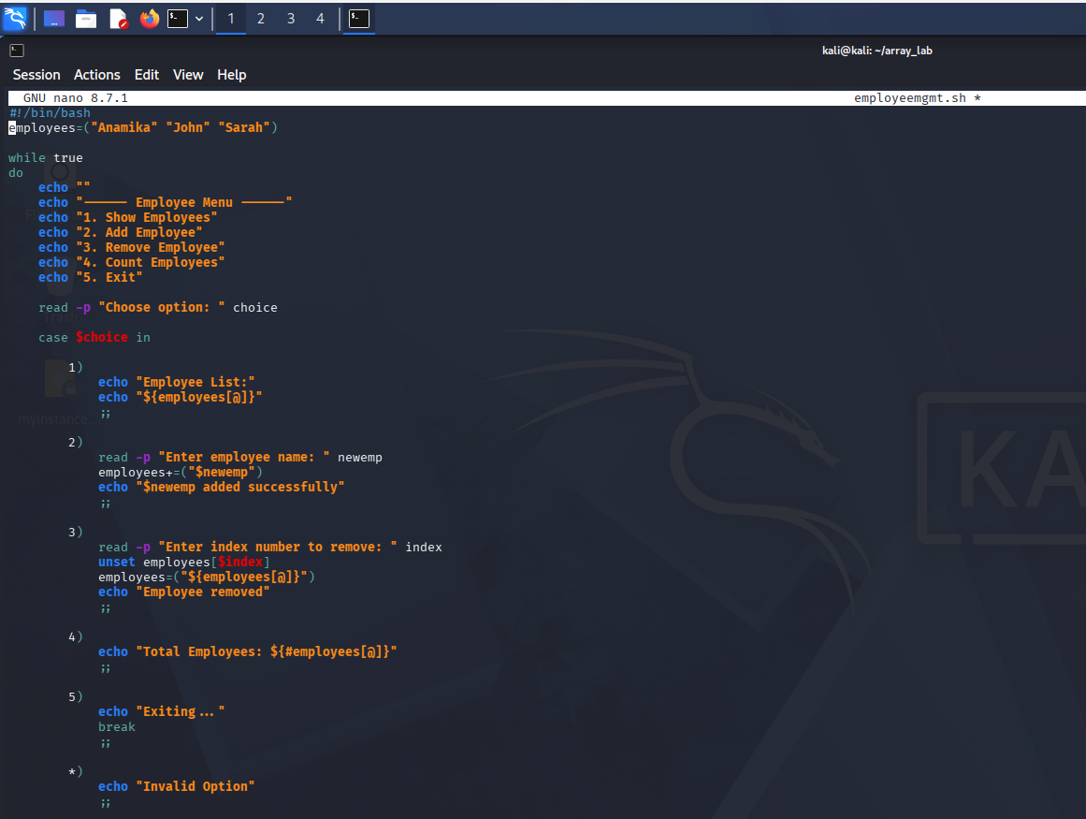
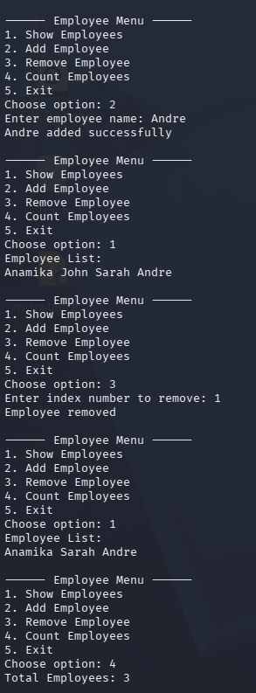
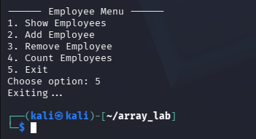

Concepts You Learned
✅ Arrays
✅ Indexing
✅ Adding elements
✅ Removing elements
✅ Looping
✅ Counting
✅ Dynamic input
✅ Automation thinking
✅ Real-world admin scripting

